JESUS AND TAGORE
CONFLUENCE OF MINDS
As human persons, Jesus and Tagore have many common attributes. They were spiritual leaders who have had great influence on their followers and readers. Tagore was also sometimes compared in the West to Jesus in his manner and appearance
That the Birth of Jesus made a deep and lasting impression on Tagore is evident from his poem, The Child. It is the only poem of Rabindranath Tagore, which is originally written in English. The piece was composed in July 1930 after his visit to the village of Oberammergau, 40 miles from Munich, Germany. Tagore visited the place to watch the traditional passion plays of Jesus Christ, held every ten years. It was later translated into Bengali as Sishutirtha (Pilgrimage to Childhood) in Punashca.
The Child is a recurrent metaphor in Tagore’s poems. The passion plays coalesced in the poet’s imagination and he conceived the Child in the harmony of creative impulse in the course of a night. Tagore finds humanity striving to transcend the burden of frustration and failure, breaking, yet refusing to be defeated and persevering with the quest. Man contains in himself the spirit of his redemption and one day, the Newborn; the divine Child shall triumph towards glorious fulfillment.
The poem is in ten sections and the actions pause and heave like the eternal waves of the sea. The poem blends the cultural contexts of the East and West, of impressionistic description and profound prophecy.

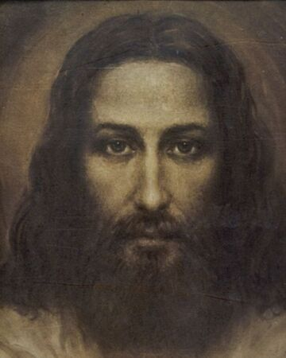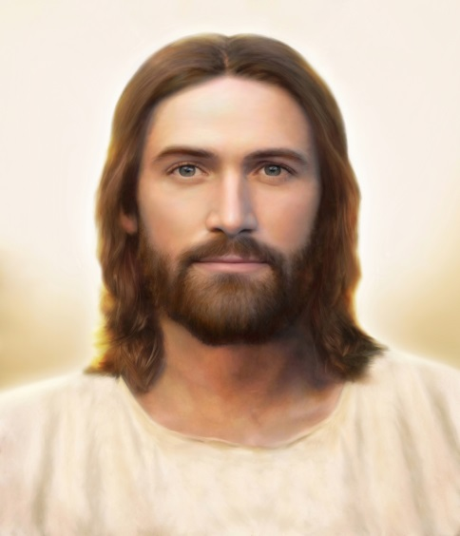
Jesus Christ

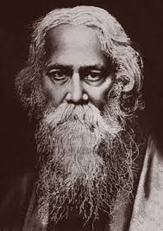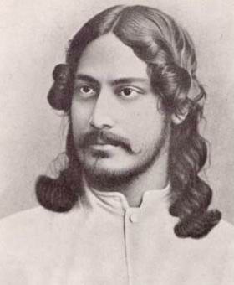
Gurudeb Rabindranath Tagore

This impression on Tagore’s mind is further borne out by his translation of Eliot’s Ariel Poem, “Journey of the Magi” (Tirtho Jatri) in search of the Divine Infant. Tagore had acknowledged the impact of Eliot’s poem, the obvious reason being that the scene of the Nativity seems to have deeply moved him. Tagore was profoundly influenced and deeply inspired by Ave Maria.
Tagore wrote another poem on Jesus Christ in 1939. He wrote these lines at the age of 78, during the period of his long illness and as death was drawing near. The poetry he wrote in these years is among the finest, and is distinctive of his preoccupation with death and transmigration. Probably he had contemplated on the sufferings and death of Jesus Christ naturally influenced by the Passion Plays he watched in Oberammergau, Germany.
The Second World War was declared on September 1, 1939. The Indian leaders had suggested that Britain should declare independence before India could help the Allied cause. The request was naturally turned down. India was not free and Europe was at war. For Christmas service at Santiniketan Tagore wrote, “To Christ, the Son of Man”:
Bengali Song in Roman Script  Aekdin jara merechilo taré giyé Rajaro dohai diyé  A yugé tarai janmo niyeche aji,  Mandiré tara aesheche bhakto shaji-  Ghatak shainyé daki  ‘Maro Maro’ othé hnaki.  Garjoné mishé pujamantrer swar-  Manob-putro tibro baethaé kahen,  Hé Iswar!  A panpatro nidarun bishé bhara  Duré félé dao, duré félé dao twawra. | English Translation  One day those who killed him,  In the name of the King  They have come back as devotees in the temples,  Assailant calls the soldier  ‘Kill him, Kill him’, yells,  The yell mixes with prayer hymns  Says he is in great pain,  This cup is full of poison,  Throw it away.

The Child (Sishutirtha)
CHRISTMAS – THE BIRTH OF THE CHILD
The birth of Jesus Christ is celebrated all over the world on December 25. On December 24 the Visva Bharati University at Shanti Niketan organises a display of lights and fireworks on Melar Maath, a custom started by the poet, Rabindranath Tagore himself. On 25th the Christmas Day, the university organises the Christo Utsab.
The Child is the only poem of Rabindranath Tagore, which is originally written in English. The piece was composed in July 1930 after his visit to the village of Oberammergau, 40 miles from Munich, Germany. Tagore visited the place to watch the traditional passion plays of Jesus Christ, held every ten years. That the Birth of Jesus made a deep and lasting impression on Tagore is evident from this poem. It was later translated into Bengali as Sishutirtha (Pilgrimage to Childhood) in Punashca.
The Child is a recurrent metaphor in Tagore’s poems. The passion plays coalesced in the poet’s imagination and he conceived the Child in the harmony of creative impulse in the course of a night. Tagore finds humanity striving to transcend the burden of frustration and failure, breaking, yet refusing to be defeated and persevering with the quest. Man contains in himself the spirit of his redemption and one day, the Newborn; the divine Child shall triumph towards glorious fulfillment.
The poem is in ten sections and the actions pause and heave like the eternal waves of the sea. The poem blends the cultural contexts of the East and West, of impressionistic description and profound prophecy.
This impression on Tagore’s mind is further borne out by his translation of Eliot’s Ariel Poem, “Journey of the Magi” (Tirtho Jatri) in search of the Divine Infant. Tagore had acknowledged the impact of Eliot’s poem, the obvious reason being that the scene of the Nativity seems to have deeply moved him. Tagore was profoundly influenced and deeply inspired by Ave Maria.
Tanushree Shankar has choreographed it. Her interpretation depicts a flowing, rhythmic spiritual journey of man through the ages from the bondage of ignorance to the freedom of enlightenment and self- realization. It is only hope and faith that take him along to the newness of life offered by the Child, full of divinity. We present the beautiful poem here for the readers to look around and see The Holy Child:

The child
The first flush of dawn glistens on the dew-dripping leaves of the forest.
The man who reads the sky cries:
"Friends, we have come!"
They stop and look around.
On both sides of the road the corn is ripe to the horizon,
The glad golden answer of the earth to the morning light.
The current of daily life moves slowly
between the village near the hill and the one by the riverbank.
The potter's wheel goes round; the woodcutter brings fuel to the market,
the cowherd takes his cattle to the pasture,
and the woman with the pitcher on her head walk to the well.
But where is the King's castle, the mine of gold,
the secret book of magic,
the sage who knows love's utter wisdom?
"The stars cannot be wrong," assures the reader of the sky.
"Their signal points to that spot."
And reverently he walks to a wayside spring
from which wells up a stream of water, a liquid light, like the morning melting
into a chorus of tears and laughter
Near it in a palm grove surrounded by a strange hush stands a leaf-thatched hut
at whose portal sits the poet of the unknown shore, and sings:
"Mother, open the gate!"
A ray of morning sun strikes aslant at the door.
The assembled crowd feels in their blood the primeval chant of creation:
"Mother, open the gate!"
The gate opens.
The mother is seated on a straw bed with the babe on her lap,
Like the dawn with the morning star.
The sun's ray that was waiting at the door outside falls on the head of the child.
The poet strikes his lute and sings out:
"Victory to Man, the new-born, the ever-living!"
They kneel down, -- the king and the beggar, the saint and the sinner,
the wise and the fool, -- and cry:
"Victory to Man, the New-Born, the Ever-Living!"
The old man from the East murmurs to himself:
"I have seen!"
• Rabindranath Tagore

==============================================================

