Jesus Christ – Paintings and Images
The oldest known portrait of Jesus in the world, found in the baptismal chamber of the Dura Europos church in 1921 which is situated on the Euphrates River in modern day Syria and dated to about 235 AD, shows him as a beardless young man of authoritative and dignified bearing. It is known as “The Healing of the Paralytic.” Jesus is depicted dressed in the style of a young philosopher, with close-cropped hair and wearing a tunic and pallium—signs of good breeding in Greco-Roman society.
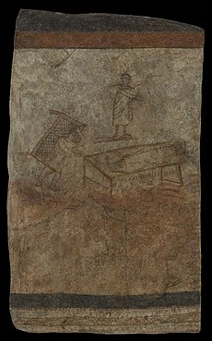
The Healing of the Paralytic – one of the oldest possible depictions of Jesus, from the Syrian city of Dura Europos, dating from about 235.
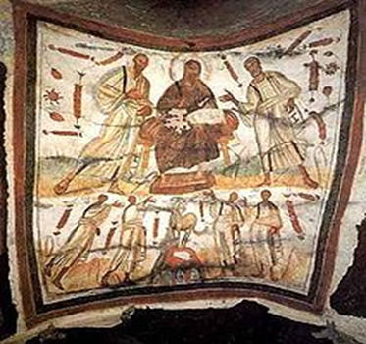
Bearded Jesus between Peter and Paul, Catacombs of Marcellinus and Peter, Rome. Second half of the 4th century. Such works "first present us with the fully formed image of Christ in Majesty that will so dominate Byzantine art".
There is no useful description of the physical appearance of Jesus given in the New Testament, and the depiction of Jesus in pictorial form was controversial in the early Church. The depiction of him in art took several centuries to reach a conventional standardized form for his physical appearance, which has subsequently remained largely stable since that time.
Most images of Jesus have in common a number of traits which are now almost universally associated with Jesus, although variants are seen.
The conventional image of a fully bearded Jesus with long hair emerged around AD 300, but did not become established until the 6th century in Eastern Christianity, and much later in the West. It has always had the advantage of being easily recognizable and distinguishing Jesus from other figures shown around him, which the use of a cruciform halo also achieves.
Images of Jesus tend to show ethnic characteristics similar to those of the culture in which the image has been created. We call these as inculturated images of the person. The Shroud of Turin is now the best-known example, though the Image of Edessa and the Veil of Veronica were better known in medieval times.

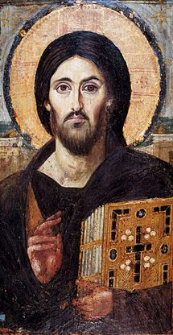
The oldest surviving panel icon of Christ Pantocrator, encaustic on panel, 6th century, showing the appearance of Jesus that is still immediately recognized today.
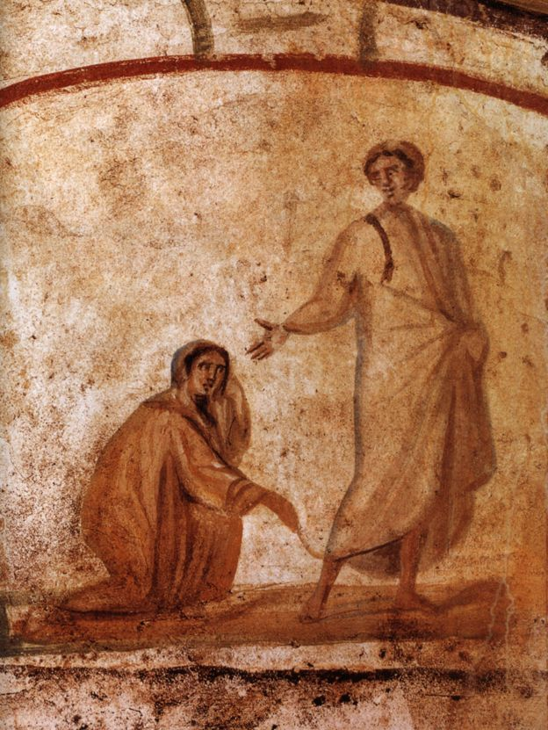
Jesus Christ healing a woman who touched his garment in the crowd 300 – 350 AD. Jesus is presented beardless here.

Another work of art (author unknown) is of “Jesus Christ healing a woman who touched his garment in the crowd.’ It is depicted in the Catacombs of Marcellinus and Peter – 300 – 350 AD. In this piece, a rare one, Jesus is portrayed beardless and clean-shaved. The Catacombs of Marcellinus and Peter are found approximately three kilometers from southeast Rome and the ancient Via Labicana and date to the 4th century AD. The catacombs were named in reference to the Christian martyrs, Marcellinus and Peter who were buried there, near the body of St. Tiburtius.
It is disappointing to know that there aren’t many early paintings or portraits of Jesus Christ. Considering that there were many kings and royal people before Jesus in Greece, Rome, Egypt, it is surprising that the earliest image available of Jesus several hundred years after his life.
It is true that the Old Testament was against the use of idols or making an image. "Thou shalt not make unto thee any graven image" is an abbreviated form of one of the Ten Commandments which, according to the Book of Deuteronomy, were spoken by God to the Israelites and then written on stone tablets by God Himself. It may be reasonable to believe that the apostles and followers of Jesus were brought up in the Old Testament traditions and were against painting his image or portrait.
It may also be right that the followers of Jesus were common people like fishermen who did not have the means to take up a project of painting which was during that era for rulers and people of power.
The vast majority of images of Jesus that are available now (including the Shroud of Turin), are too European or Roman looking. They fail any chance of being an accurate depiction.
Some documentaries on the life of Jesus have taken the position that Jesus looked like a typical Semitic (i.e. Arab) man of the first century. These may be correct. He is reportedly shorter, probably had cropped, shorter, curly hair, and darker skin than everyone imagines.
The Real Face of Jesus:
The European portrait of Jesus is such a common image that everyone easily recognizes Jesus. But did he really look like this. Probably not!
Advances in forensic science reveal the most famous face in history. An answer has emerged from an exciting new field of science: forensic anthropology. Using methods similar to those police have developed to solve crimes, British scientists, assisted by Israeli archeologists, have re-created what they believe is the most accurate image of the most famous face in human history (https://www.popularmechanics.com/).

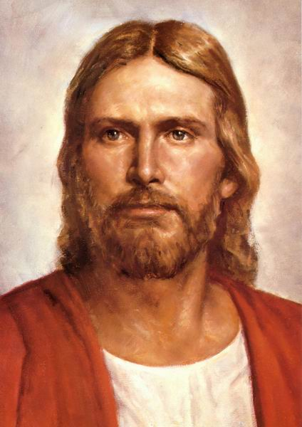
European looking portraits of Jesus

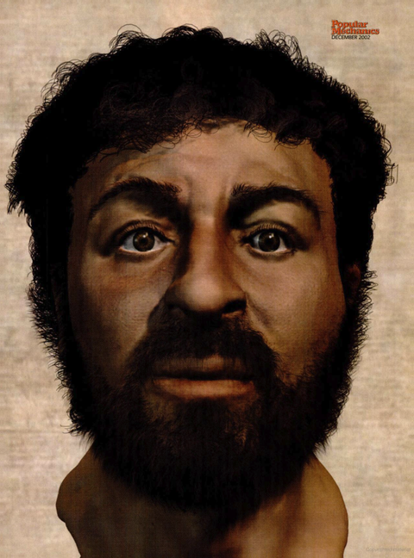
The digitally recreated face of Jesus.

