Indian Images of Jesus:
"In India, people form images of Jesus Christ that link up with their culture. Hindus have given Jesus a place among the teachers and gods of their own religion, seeing in his life something of the wisdom and mysticism that is so central to Hinduism"
"Christians in India also make use of the concepts provided by Hinduism when they wish to express the meaning of Christ. Thus, in any case, Jesus is-for Hindus and Christians-a guru, a teacher of wisdom who speaks with divine authority."
"But for many Hindu philosophers and Christian theologians much more can be said about him within the Indian framework. He can be described as an avatara, a divine descent, or linked to the Brahman, the all-encompassing Reality." (Jan Peter Schouten in his book: Jesus as Guru: The Image of Christ among Hindus and Christians in India, 2008). Let us see some of the Indian presentations of Jesus:
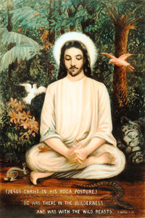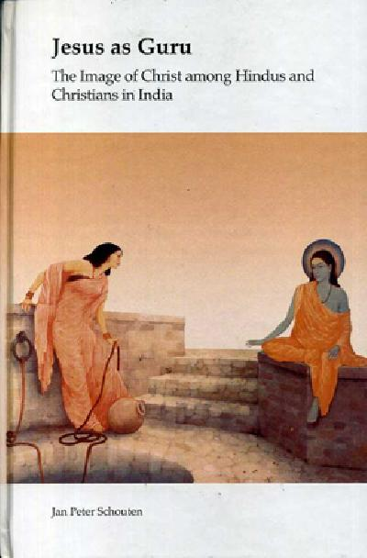
Jesus as Yogi Jesus at the well
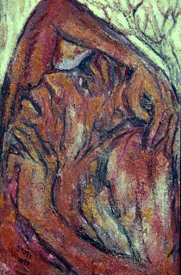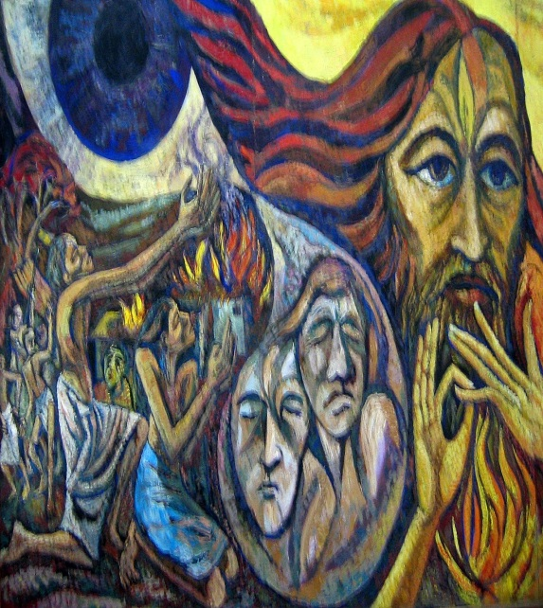
Jesus as a Dalit by JyothiSahi Jesus as an Adivasi by JyothiSahi

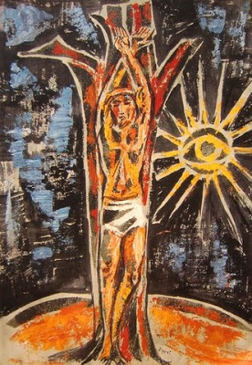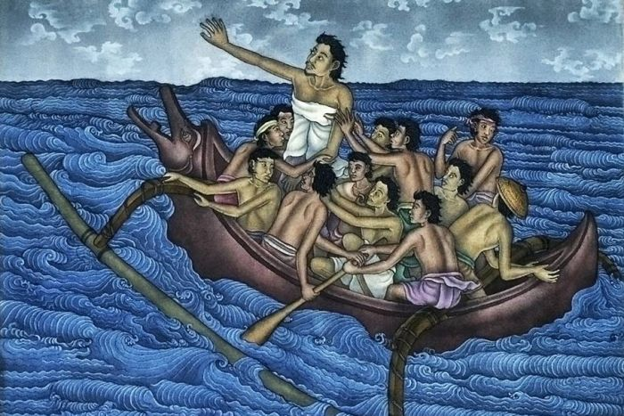
Jesus on the Cross by JyothiSahi Jesus on the boat with his disciples

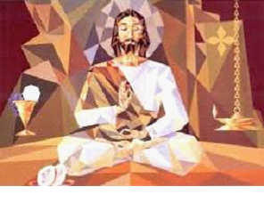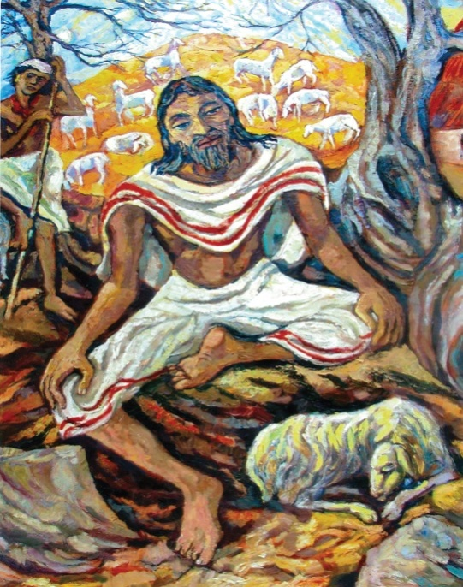
Jesus in a squatting position Jesus the Good Shepherd by JyotiSahi

