Jesuits!
Want to join the Company?
The Society of Jesus (SJ; Latin: SocietasIesu) is a religious order of the Catholic Church with its headquarter in Rome. It was founded by Ignatius of Loyola with the approval of Pope Paul III in 1540. Membership is only for men and the members are called Jesuits (Latin: Iesuitæ).
The society is engaged in various types of works in 112 nations. Jesuits work in education, research, and cultural pursuits. Jesuits also give retreats, minister in hospitals and parishes, sponsor direct social ministries, and promote ecumenical and inter-religious dialogue.
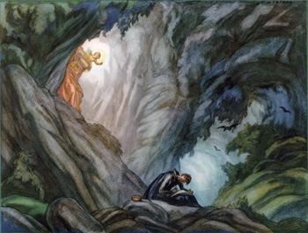
St. Ignatius writing his Spiritual Exercises in a cave (now called The Cave of Saint Ignatius) near Manresa, which is called the cradle city of the Jesuit Order.

HAVE YOU SERIOUSLY THOUGHT OF JOINING THE JESUIT ORDER?
- One can join after Plus 2 or after undergraduate studies.
- You may join even after some years of work / service.
- Find out whether there are Jesuits or Jesuit institution in your hometown or nearby.
- If not, write to us: felixrajsj@gmail.com or contact@felixrajsj.com
- Telephone: 9831207444 / 66249812 / 9888 / 9810
- Address: St. Xavier’s University, New Town, Kolkata – 700 160
- Besides your secular studies depending on your ability and the Superior’s approval, Jesuit formation includes:

  - One year of pre-novitiate (if necessary): to learn sufficient English, local language and culture; candidates are exposed to Jesuit community and apostolic life.

      - I had 6 months of pre-novitiate in Patna learning English and Hindi.

  - Two years of Novitiate: Spiritual Exercises and Growth; Understanding of Jesuit spirituality, way of life; experiments and trails; included a month’s retreat. At the end of the novitiate, the novice is invited to pronounce his first vows of chastity, poverty and obedience.

      - I had two years of novitiate in Patna, at XTTI.

Novitiate in Kolkata:https://www.dhyanashram.org/

  - One year of Juniorate: period of studies in humanity and communications. Proficiency in English and the local language – greater understanding of literature and other forms of arts.

      - I had one year of Juniorate in Patna at XTTI

  - Two years of Philosophy: Studies in philosophy – development of critical thinking to understand his own choice of life and gain critical self-awareness.

      - I studied two years of Philosophy at JDV, Pune

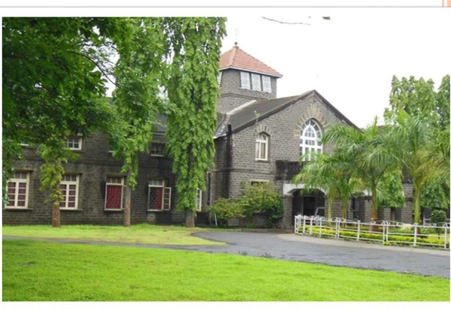
Jesuit Philosophate: De Nobili College, Pune
https://jdv.edu.in/
  - One or two years of Regency: Teaching or any appropriate institutional assignment; living in an apostolic community and interacting with formed Jesuits.

      - I spent two years of regency at St. Xavier’s College teaching economics.
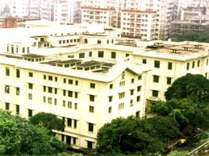

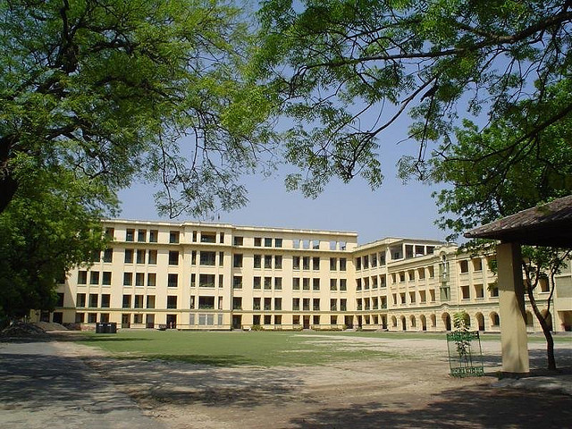
St. Xavier’s College, Kolkata

  - Four years of Theology: The final stage before ordination to priesthood, Academic theological studies; Rootedness in God, Apostolic effectiveness – A Comprehensive examination to test his spiritual, intellectual, moral, ecclesiastical and historical understanding.

      - I had my three years of theology at Vidyajothi College, Delhi and attended my comprehensive exam later in the month of October after my ordination.
Jesuit Theologate in Delhi: http://vidyajyoticollege.in/
  - Priestly Ordination: This is the final stage. All the years of formation culminate in the ordination to priesthood. The Jesuit priest becomes an instrument in the hands of his Creator for priestly ministry.

# Jesuit formation includes 12 years besides secular studies – BA, MA / MSc and Ph.D. It may take 15 to 16 years to complete the whole formation.
# Till the ordination to priesthood, a Jesuit is called a scholastic (one in training).
Tertianship: Itis a 5 month final period of formation in the Society of Jesus after three to five years of having worked in a field of Jesuit mission.It is a time in which an individual steps back to critically assess his experience of living and working in the Society of Jesus and whether this is, in fact, the life to which he is being called by Christ.During this time, the Jesuit in formationis called a "tertian" and heundergoes a thirty-day silent retreat based upon the Spiritual Exercises of St. Ignatius of Loyola under the direction of a tertian master.It is something like a second novitiate or third year of novitiate.
- I made my Tertianship at Sitagarah, Hazaribagh.

Final Vows: Final vows follow a few years aftertertianship. After having been satisfied and found the candidate fit, the General of the Society of Jesus invites the Jesuit to pronounce the final perpetual solemn vows of poverty, chastity and obedience, and also a fourth vow (only for some) unique to Jesuits, of special obedience to the Pope in matters regarding mission, promising to take any mission assigned by the Pope.
Only the professed of the Four Vows are eligible for posts like novice master, provincial superior or assistant to the general of the society.
The professed of the Four Vows take, in addition to these solemn perpetual vows five additional Simple Vows: 1. not to consent to any mitigation of the Society's observance of poverty; 2. not to "ambition" or seek any prelacies (ecclesiastical offices) outside the Society; 3. not to ambition any offices within the Society; 4. a commitment to report any Jesuit who does so ambition; and5. If a Jesuit does become a bishop, to permit the General to continue to provide advice to that bishop, though the vow of obedience to Jesuit superiors is not operative over matters undertaken as bishop.
Under these special vows, no Jesuit may "campaign" or even offer his name for appointment or election to any office, and if chosen, one must remind the appointing authority (even the Pope) of these Vows—if the Pope commands that the Jesuit accept ordination as a bishop anyway, the Jesuit must keep an open ear to the Jesuit general as an influence.

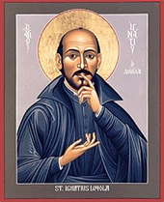

In 2018, there were 11,389 priests and 4,453 Jesuits in formation (Scholastics).

Jesuits in the World
Year Number of Jesuit
1900 15,073
1914 16,894
1965 36,038
1985 25,549
2012 17,637
2013 17,287
2018 15,842

Pope is a Jesuit:
In 2013, Jorge Mario Bergoglio from Argentina became the first Jesuit to be elected Pope, taking the name Pope Francis.
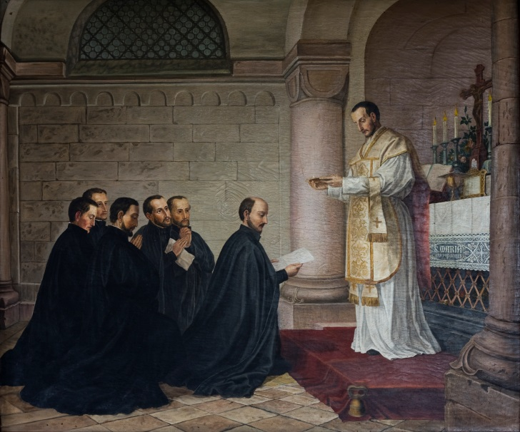
German painter, Baumeister's painting of first companions
Ignatius Loyolawith his six first companions: Francis Xavier, Peter Faber, James Laínez, Simon Rodrigues, Alfonso Salmerón andNicholás Bobadilla

?
Do you want to know how I joined the Jesuits? Here you have a personal account. Log on to the link:
https://www.telegraphindia.com/states/west-bengal/lord-ganesh-surprised-me/cid/1701903

Do you desire to know more about Jesuits and their work? Log on to this Link:
https://epaper.telegraphindia.com/imageview_283915_15836944_4_71_31-07-2019_14_i_1_sf.html

IHS

"IHS"monogram or Christogram, is interpreted as meaning IesusHominumSalvator ("Jesus, Savior of Mankind", in Latin. IHS monogram in gold-blue is the logo of the Society of Jesus.
The Christogram IHS is a monogram symbolizing Jesus Christ.From Greek it is an abbreviation of the name IHΣΟΥΣ (Jesus).
In Eastern Orthodox Church the Christogram is composed with letters X, P, I and X arranged into the cross. They are the first letters of one from two words in Greek language: Christ and Jesus Christ.
In the Western culture there exist the compositions: "IHS" and also "IHC" being the first letters (iota-eta-sigma) of the name Jesus in Greek alphabet: ΙΗΣΟΥΣ (Ίησοῦς or ΙΗϹΟΥϹ with lunated sigma). The abbreviation in form "IHS" appeared in first time on the coins of Justinian II on the turn of the 7th and 8th centuries.
The Jesuit Order (SocietasIesu), adopted IHS as its fixed emblem - the symbol in 17th century. There appeared also Latin interpretations of the abbreviation IHS, among others:
IesusHumilisSocietas - Humble Society of Jesus,
IesusHominumSalvator - Jesus, Savior of men.

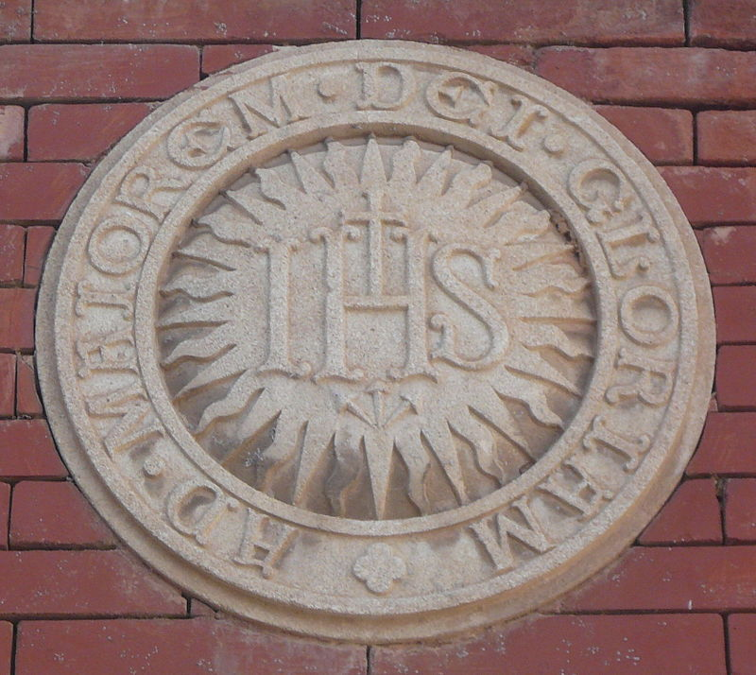

AMDG
Ad maiorem Dei gloriam or Ad majórem Dei glóriam, also rendered as the abbreviation AMDG, is the Latin motto of the Society of Jesus (Jesuits). It means "For the greater glory of God."
The origin of the phrase is attributed to the founder of the Jesuits, Saint Ignatius of Loyola, who intended it to serve as a cornerstone sentiment of the society’s religious philosophy. It is a summary of the idea that any work that is not evil, can be spiritually meritorious if it is performed in order to give glory to God.

ABOUT JESUITS:
"Though few in number, the basic principles that Ignatius of Loyola had set for his Company were powerful catalysts. Once his men harnessed their energies within his organization to the worldwide work, they produced a unique phenomenon of human history.”
That is why the eighteenth-century German theorist, Novalis wrote:
"Never,", "never before in the course of the world's history had such a Society appeared. The old Roman Senate itself did not lay schemes for world domination with greater certainty of success. Never had the carrying out of a greater idea been considered with greater understanding. For all time, this Society will be an example to every society which feels an organic longing for infinite extension and eternal duration ....."
(Malachi Martin, The Jesuits p. 27)
DROP A LINE OR COME OVER FOR A CHAT:
If you desire to know about Jesuits or want to join them, drop a line or meet a Jesuit in your locality or institution or come over for a good chat.
Dr. Fr. Felix Raj, SJ
St. Xavier’s University
New Town, Kolkata – 700 160
Email: contact@felixrajsj.com
@@@@@@@@@@@@@@@@@@@@@@@@@@@@@@@@@@@@@@@@

